**1. Application Types.**

**2. Difference between web application and Distributive application.**

**3. Terminology used in Programming Language.**

**4. History of Java.**

**5. Versions of Java.**

**6. Editions of java.**

**7. Types of Java Softwares.**

**8. Java Language Features.**

**4. History of Java:**The James gosling, Mike Sheridan and Patrick naughton were working as professor at sun Micro systems in 1991. The sun micro system was university. The Applications for consumer electronic devices such as washing machines, microwave ovens was developed by c, c++ devices. In 1991, James gosling team got a new requirement. That is developing application for networked consumer electronic devices.

Networked consumer electronic devices:- The two electronic devices are communicated via either wireless network or wired network. The compiled data is transferred between devices across network. Therefore while travelling **security is required for data and data must be executed on another device irrespective of another device hardware.**

Example: Tv and remote.

Air conditioner and remote.

Both are two devices.

At that time, there were only c,c++ ,simula languages. But these languages were not suitable for developing such applications Because platform dependent languages.

James gosling need to develop the new programming language. After lot of work and 4 years, He invented new language. It did not have name. James gosling wanted to set a name to new language. While thinking, he came to window at office and opened the window shutter. He saw tree. It was OAK tree. It was big and strong tree and national tree in that tree. He selected tree name as new language name.

He was unable to register this PL with name OAK because with same name had been used by another company called OAK Technologies. Meanwhile, www was emerging into a market. In www so many verities of CPUs under different s/w and H/W environments(window,solaries…etc) will be connected. So james gosling knows that we require one language to develop platform independent applications/Internet based Business applications.

He and his team started enhancement of OAK. He name to enhancement project ‘GREEN PROJECT’. This is dummy name. Later it is renamed to JAVA. This name was proposed by one of team member.

There is no abbreviation for java. The name java specifically does not have any meaning rather it refers to **hot, aromatic drink coffee**. The name is just derived from coffee cup. That is reason Java programming language icon is coffee cup.

**5. Java Versions:** The version is number. It is used to identify the available features in the software. Sun Micro system first released Java on jan 23, 1996. Java has two types of versions.

1. Major Version:- It is main version of software contains new features.

2. Minor version:- It is sub version of main version contains bug fixes.

Example:

Main version: JDK 9.0

Minor Versions: JDK 9.0.1, JDK 9.0.2…etc.

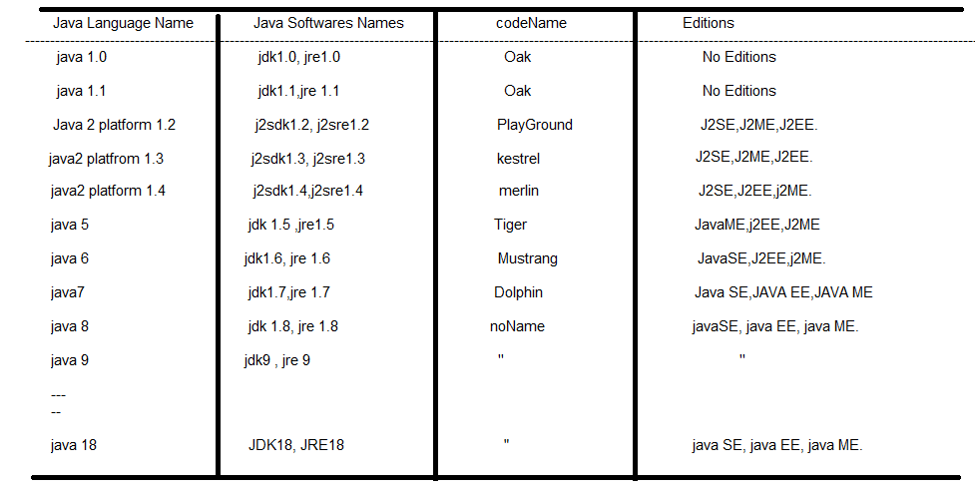

* The java language is versioned and java software is also versioned.
* Upto java 9 version, we get new version of java software for 1,2,3,4 or 5 years once.
* After 9v, oracle corporation releases 2 new versions per year. Earlier version is released in March and later version is released in September month.
* Code name is java software internal project name used in sun microsystem.
* LTS(Long Term support) versions:- when new version is released into market, the sun micro system(oracle) announces that new version is LTS version or non LTS version.If it is LTS version, the new version can be downloaded and used. Other wise it is non LTS version.

Example: java8.0,java11.0, java 17.0

When we try to download **non LTS** version into local machine, browser automatically redirect us to LTS version.

**6. Java Editions:**The sun micro systems divided java concepts into 3 categories. Each category is called a Edition.

The editions are

6.1. Java SE(standard Edition)

6.2. java EE (Enterpraise Edition)

6.3. java ME(Micro Edition).

**6.1. Java SE:-** It has concepts and technologies.

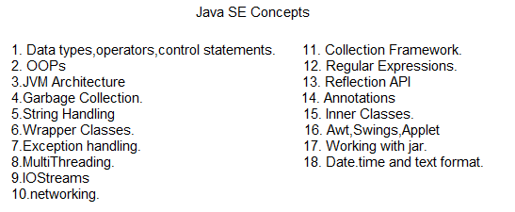

Q) What is Technology?

A) The API is a library. It contains the several programs. When this API enables data transmission between two different software products, This API is said to be Technology.

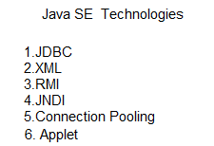

Using javaSE, we can develop the following applications.

1. Standard alone Applications using core java concepts.

2.Web supportive applications using Applet.

3. Distributed Applications using RMI technology.

4. Integrated Applications using XML technology.

5. DataBase Interaction Application using only JDBC technology or JDBC,JNDI and Connection Pooling Technology jointly.

Note:- Applet ,RMI, XML are outdated technologies. In Industry, In the place of XML , JSON is being used and in the place of APPLET technology, HTML,CSS and JS are being used.

**6.2. java EE**:- It has only technologies.

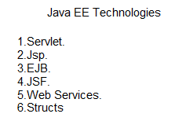

Using java EE, we develop the following applications.

1. Web applications using servlet, jsp.

2. Enterprise Applications using EJB.

3. Interoperable Applications using webservices.

Note:- Struts,JSF and webservices are outdated technologies.

**7. Types of Java Software:**The java software is divided into two types.

7.1)JDK.

7.2)JRE

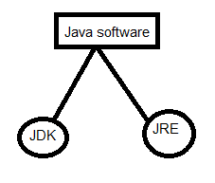

**7.1.JDK:-** when we install JDK,JRE is also installed automatically. JDK has bothDevelopment tools(compiler, documentation generation program, tools, jar creation program, debugger…etc) and JRE. Developers develop the new programs and Developers compile and execute the new programs in development Environment . Therefore JDK has to be installed in development environment.

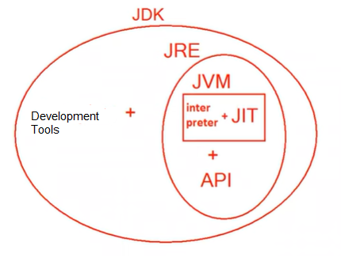

**7.2.JRE:-** JRE software is available as separate pack, so we can install JRE alone. JRE has only JVM. Hence using JRE we can only execute already developed applications. JRE has only to be installed in Testing environment. Because testers just execute the application for testing. The JRE contains JVM and API(Library)

Note:- Sun micro system(oracle) developed **individual JVM** for every operating system.

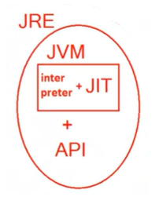

The Interpreter, JIT and associated filesjointly is called JVM.

JIT(Just in time compiler):- The invocation of compiler is happened just before the interpretation. JIT analyzes the byte code and remove the redundancy so that interpretation happens very speedly.

Example:

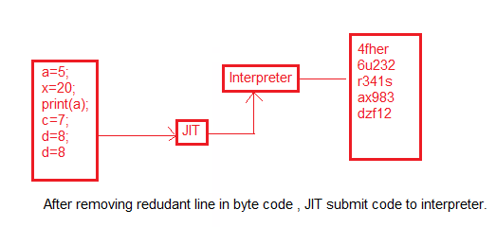

**Note:-** Java11 onwards , The JRE is not separately available . It becomes the part of JDK.

Reason:- Once upon a time,.awt, .swing packages were used to develop the front-end applications. These application usually run at client side. To run them, JRE was needed and installed at client machine. But Now days ,Front-end applications are completely developed using HTML,CSS and JS technologies. Nobody uses the .awt and .swings packages. This is one reasone to place JRE as part of JDK.

**8. Java Language Features:**

**8.1) Simple:-** Java is easy to learn and its syntax is quite simple and easy to understand. The confusing and difficult concepts (pointers,operator overloading)of c++ are left out java.

**8.2) Object Oriented:-** The java strongly supports OOPs concepts due to which it is called object-oriented language. The concepts are

* + - class
    - object
    - Encapsulation
    - Inheritance
    - Abstration.
    - polymorphism.

The java is not fully object-oriented programming language Because of following reasons.

1. java has predefined primitive data types(which are not objects).

2. You can access the static member of class with out creating the object.

**8.3) Architectural –Neutral:-**

### 

### Windows7 was installed in computer. Its current ram size is 2gb. Its processor is p3. Due to some reasons, I updated current system architecture. I replaced the windows7 with windows10. I increased the ram size. I removed existing processor. I placed latest processor.

### Eventhough I made changes in existing computer architecture, The java program can run successfully with out any modification. This feature is architectural netural.

### 8.4)Robust:-Robust simply means strong.The java program may fail at run time due to following reasons.

1. Incomptability data types.
2. In-sufficient memory space.
3. Runtime-errors.

### There is static type checking mechanism in java. Then compiler finds the data type errors at compile time. It displays errors messages to user. Therefore syntax mistakes are’t transferred to execution state. Chance of program fail at run time is very less due to type related errors.

* There is automatic garbage collection mechanism in java which runs on the Java Virtual Machine to get the objects which are not being used by a Java application anymore. By removing them, More space is available to application at run time.
* There is exception handling mechanism in Java. This mechanism handles runtime errors. Therefore program execution is continued normally, even errors are occurred at run time.

By 3 mechanisms,chance to fail program at run time is very less. That’s why java is robust.

**8.5) platform Independent:-**

**8.5.1.Platform:-** Platform is environment in which program is loaded and executed. The platform is software, hardware of both.

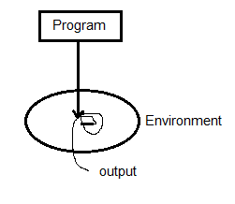

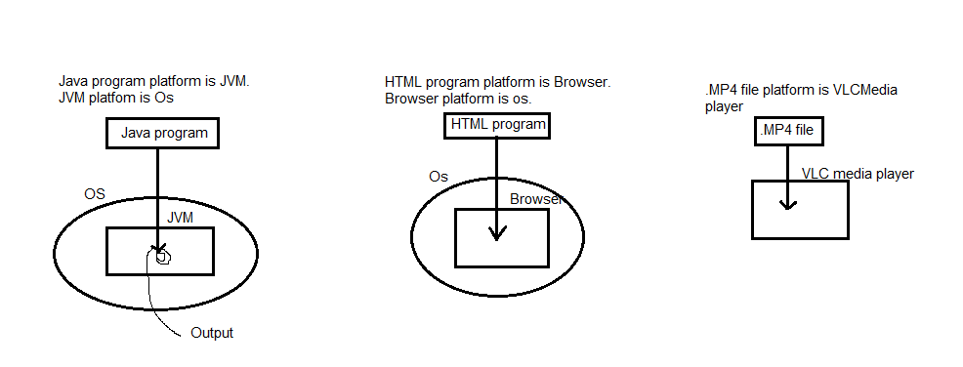

**8.5.2.PlatformDependency:** The program that is compiled in OS, if it can’t be executed in another OS , it is called platform dependent program.

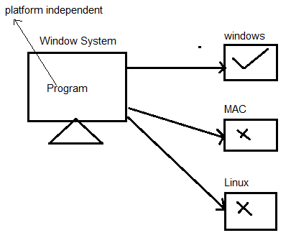

The programswhich is written in c, c++ language are platform dependent programs.

The abc.c contains source code. The source code is given to c compiler. The c compiler generates ML code of current OS.Generated ML code is written in abc.obj. Though the ML code can be understood by OS, Itcan not be executed on other than windows. Because ML format is vary from OS to OS.

C,C++,Java languagesoft ware is also platform dependent languages.

**8.5.3.Platform Independency:-** The program that is compiled in os ,if it can run in another OS, it is called platform independent program.

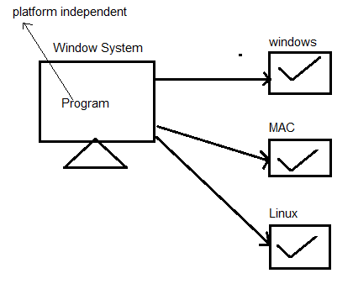

The programs which is written in java is platform independent.

The Java software is **not platform independent**.

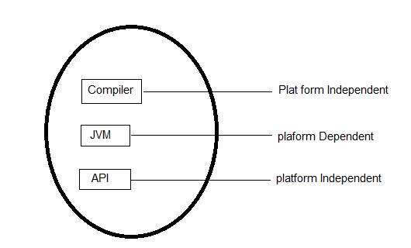

Consider Example:

If student failed in one subject among 6 subjects. If anybody ask him do you pass in semester?

He replied that I failed. Even though he passed 5 subjects , he said fail.

Even though API and Compiler is platform independent, Java software (JDK) missed platform independency feature because of JVM.

How Java Achieved Platform Independent:

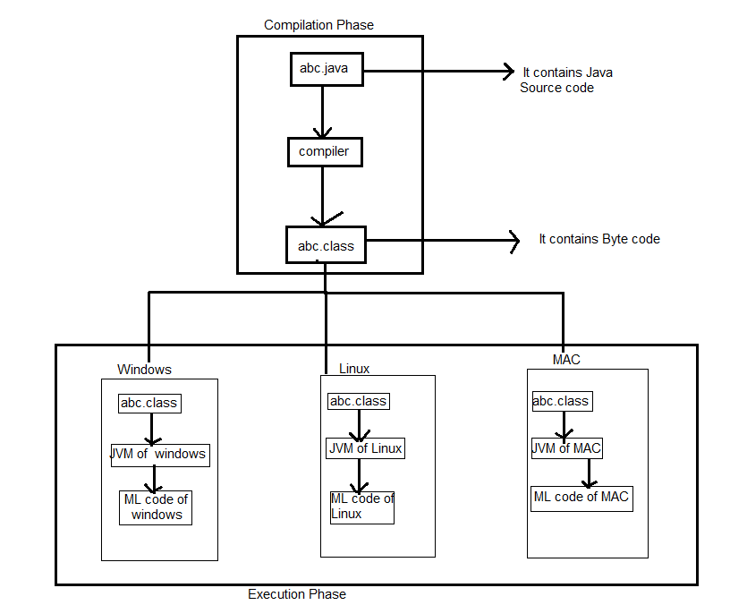

To achieve platform independent, James gosling and his team invented a new format codecalled byte code. It can only be understood by JVM.

Step1: After submitting abc.java to java compiler, compiler converts java source code into byte code and compiler writes byte code into abc.class file.

Note:- At the time of compilation only, .class file is generated by compiler.

Step2: when we submit byte code to JVM, JVM convert it into current client OS understandable machine language for executing code.

Note:- At the time of execution only, ML code is generated.

**8.6)Portable:-** Java is portable because it facilitates you to carry the Java bytecode to any platform. It doesn't require any changes in bytecode.

**8.7)Security**:-The java program is compiled by java compiler. Java compiler generates .class file. This file contains the byte code instructions. This .class file is submitted to JVM. After submitting , JVM check that it is developed by valid compiler or not.Because humans or virus program may generate .class file to damage the system/application. That .class file might submit to JVM. That’s why JVM checks that. If JVM find any thing wrongly, them jvm displays error message instead of execution.

For that, java is secure.

**8.8)Multi-threaded:-**Multithreaded means handling multiple tasks simultaneously. Java supports multithreaded programs. This means we need not wait for application to finish the one task before the another task.

Example: we can listen audio clip while page is scrolling and at the same time download applet from server.

This feature greately improves the interative facility.

**8.9)Compiled &Interpreted:-** Usually,programming language is either compiled or interpreted. The java is both compiled and interpreted language Because of

1. The java code is translated into byte code instructions by the compiler. This byte code instructions are not machine language instructions.
2. Java interpreter generates machine language instructions from byte code instructions.